EMAIL SET-UP
**Required. Incomplete forms will be returned. Please submit to cansupport@aclu.org.

If you have not already, please schedule the email on the CAN Calendar.

Affiliate Name ** | Kansas

Target Audience **
☐ Affiliate Full List
x Segmented list (Please provide zip codes, chapter code or any other geo-information below. Please separate zip codes with a comma.)
Crawford County only – 66711, 66712, 66724, 66734, 66735, 66743, 66746, 66753, 66756, 66760, 66762, 66763, 66780

Testers and Reviewers **
Please provide the email address of those that should receive a test version of this email. One person from your affiliate should respond to the CAN team with edits from all members of your affiliate team. Please don’t have everyone reply directly to the CAN team.
ayoung@aclukansas.org; mbata@aclukansas.org; mkubic@aclukansas.org

Email Template **
Note: Images are required for the Action, Event and Banner format emails.

☐ Letter format  (no image) | ☐ Action format  (image 190x230) | x Event Template  (image 350x300) | ☐ Banner Format  (Image 600x300)
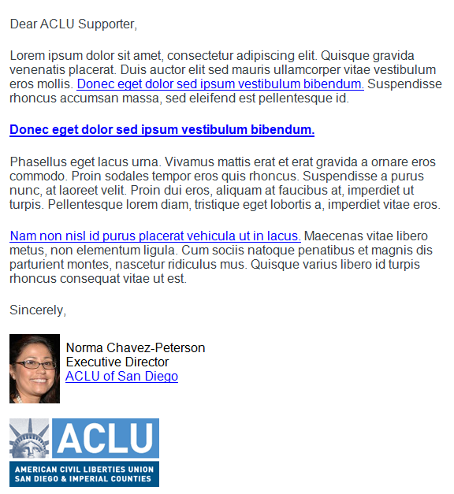 | 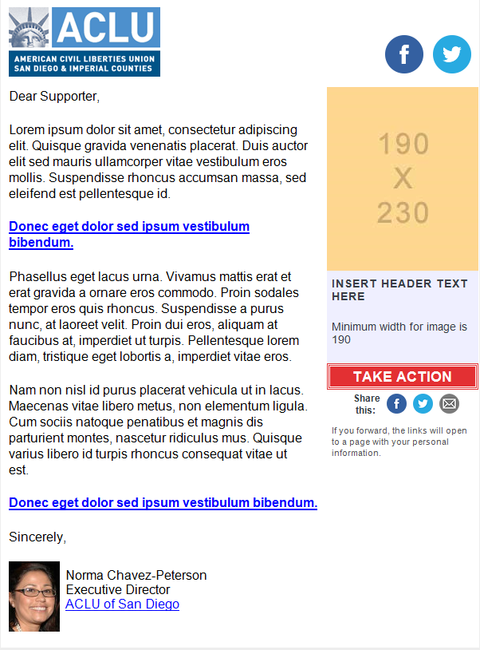 | 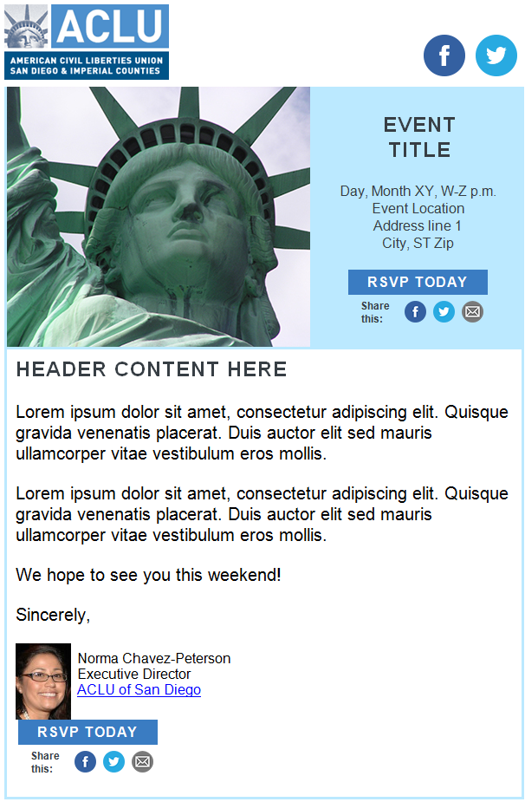 | 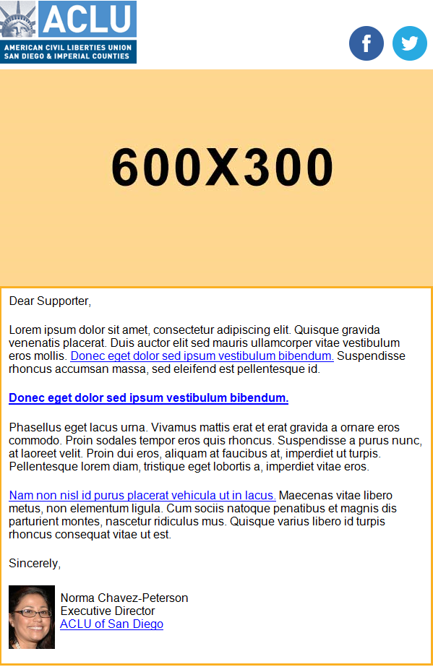

Subject line **
Tease, tell or take action. Avoid initial caps, keep it under 50 characters, and make it compelling for constituents to open your email. Avoid the words “Help,” “Act,” “Marriage,” “Immigration,” “Immigrant,” “Action,” ” Let’s,” and “Save the date.”
Join us in Pittsburg for our We the People tour!

Pre-header Text **
The pre-header is the short summary text that follows the subject line when an email is viewed in the inbox. It is right about the header logo. Include a call to action.
An invitation for November 13

Side Box Content (Action & Event format only)
We the People Training Tour
5:30 – 6:30 PM
Pittsburg Public Library
308 N. Walnut St.
Pittsburg, KS
66762

Hyperlinks for email message **
www.aclukansas.org
https://go.peoplepower.org/event/action_attend/10727

Email Body Content **
Keep the content brief. One of the worst mistakes we make is trying to include the entire story into the email message. Think about when you open an email in your inbox. Do you read every single word in there? Probably not. Find a way to summarize the content compelling way, and let them click through to a page on your website for more information.

Answer the these three questions for the reader when you write your message:

- What are you asking me to do? Always give the reader an action to take. Your call to action should be able to stand-alone. Remember, people scan their emails, and if there is one thing you want your recipient to notice, it is your call-to-action.
- What is in it for me? You know the value of your email content, but does your recipient? Tell them why taking action is important for them or why they should attend an event.
- Why should I care? Write in the second person – orient the copy toward the reader and not the ACLU. Readers take action on things that are about them or affect them.
Dear supporter,

Over the past year, we’ve faced some of the most severe attacks on civil liberties in generations. But thanks to the support of activists like you, we’ve been able to fight back harder than ever before to protect civil rights and liberties in Kansas and across the country.

We’re embarking on a training tour to meet activists fighting for a better Kansas in every corner of the state. Join us on Monday, November 13, at the Pittsburg Public Library for our We the People tour! You’ll hear what we're doing to protect civil liberties in our state, meet other ACLU supporters in your area, and learn how you can make a difference in your community.

WHAT: We the People Training Tour

WHEN: 5:30 p.m. November 13, 2017 (Monday)

WHERE: Pittsburg Public Library – 308 N. Walnut St.

RSVP at https://go.peoplepower.org/event/action_attend/10727

We look forward to seeing you there!

Micah Kubic
Executive Director

Social Share Buttons **
Social share buttons are added to the Action and Event templates. Please provide the language below for Twitter. We cannot customize the email or Facebook links.

Twitter:
Join me for @aclukansas We the People training tour!

